Name: D.Darshan Course code:DSA0602
Reg no:192524117

Class Lab Practical

Set 1: Monthly Sales Data
Dataset: Monthly Sales
- Create a line chart to visualize the monthly sales. Label the axes and title the chart appropriately.
- Generate a bar chart to display the top-selling products for the year. Label the chart elements.
- Develop a scatter plot to explore the relationship between advertising budget and monthly sales. Explain the insights drawn from the scatter plot.
- Build an interactive dashboard combining the line chart and bar chart to allow users to explore sales data interactively.
Python Program:
import pandas as pd
import matplotlib.pyplot as plt

# Read your CSV file
data = pd.read_csv("Book1.csv")

# Line Chart
plt.plot(data["Month"], data["Sales (in $)"], marker="o")
plt.title("Monthly Sales")
plt.xlabel("Month")
plt.ylabel("Sales ($)")
plt.show()

# Bar Chart
plt.bar(data["Product"], data["Product Sales"])
plt.title("Top Selling Products")
plt.xlabel("Product")
plt.ylabel("Sales")
plt.show()

# Scatter Plot
plt.scatter(data["Advertising Budget"], data["Sales (in $)"])
plt.title("Advertising Budget vs Monthly Sales")
plt.xlabel("Advertising Budget")
plt.ylabel("Monthly Sales")
plt.show()

print("Insight: As the advertising budget increases, monthly sales also tend to increase.")

Output:
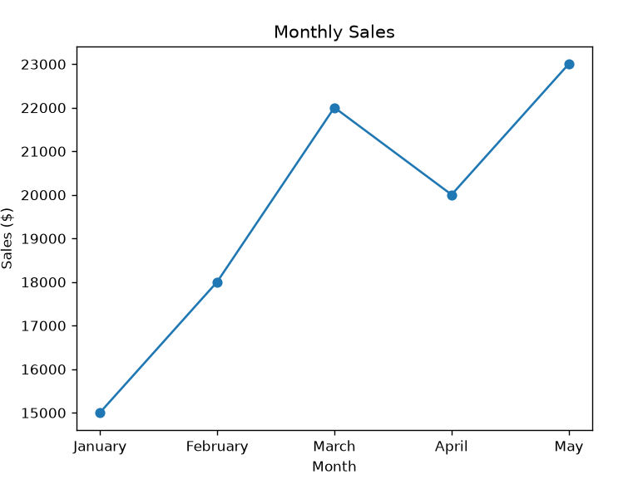

Set 2:Dataset: Customer Satisfaction
Customer ID | Age | Satisfaction Score
1 | 25 | 4
2 | 30 | 5
3 | 35 | 3
4 | 28 | 4
5 | 40 | 5

1. Create a histogram to represent the distribution of customer ages. Label the axes and title the chart.
2. Generate a pie chart to display the overall distribution of customer satisfaction scores. Include labels.
3. Build a stacked bar chart to visualize the distribution of customer satisfaction scores by age group.
4. Develop a word cloud from open-ended customer feedback to identify prevalent customer sentiments.
Python code:
import pandas as pd
import matplotlib.pyplot as plt

# Read CSV file
data = pd.read_csv("Book2.csv")

# 1. Histogram
plt.hist(data["Age"], bins=5)
plt.title("Distribution of Customer Ages")
plt.xlabel("Age")
plt.ylabel("Frequency")
plt.show()

# 2. Pie Chart
score = data["Satisfaction Score"].value_counts()

plt.pie(score, labels=score.index, autopct="%1.1f%%")
plt.title("Customer Satisfaction Scores")
plt.show()

# 3. Stacked Bar Chart
data["Age Group"] = pd.cut(data["Age"],
bins=[20, 30, 40, 50],
labels=["20-30", "31-40", "41-50"])

table = pd.crosstab(data["Age Group"], data["Satisfaction Score"])

table.plot(kind="bar", stacked=True)
plt.title("Satisfaction Score by Age Group")
plt.xlabel("Age Group")
plt.ylabel("Count")
plt.show()

Output:
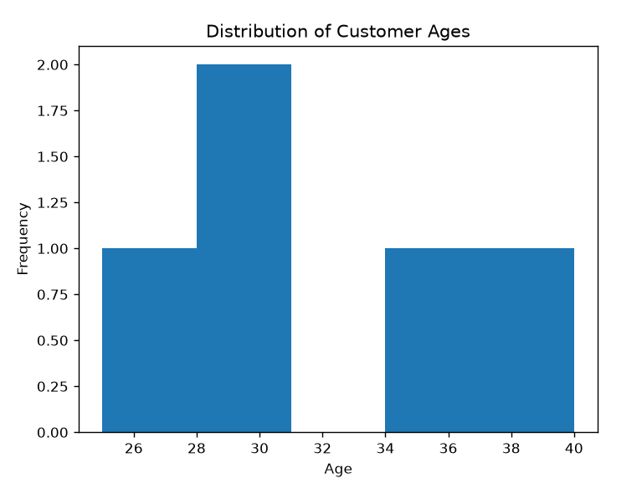

Set 3: Employee Performance Evaluation
Dataset: Employee Performance
Employee ID | Department | Years of Service | Performance Score
1 | Sales | 5 | 85
2 | HR | 3 | 92
3 | Marketing | 7 | 78
4 | Sales | 4 | 90
5 | HR | 2 | 76

1. Create a line chart to visualize the performance trend of employees over time. Include a legend and labels.
2. Generate a bar chart showing the distribution of employees across different departments. Label the chart elements.
3. Build a scatter plot to analyze the correlation between years of service and performance scores. Explain any insights.
4. Develop a Tableau dashboard with the line chart and bar chart for interactive exploration
Python program:
import pandas as pd
import matplotlib.pyplot as plt

# Read CSV file
data = pd.read_csv("Book3.csv")

# 1. Line Chart
plt.plot(data["Employee ID"], data["Performance Score"], marker="o", label="Performance")
plt.title("Employee Performance Trend")
plt.xlabel("Employee ID")
plt.ylabel("Performance Score")
plt.legend()
plt.show()

# 2. Bar Chart
dept = data["Department"].value_counts()

plt.bar(dept.index, dept.values)
plt.title("Employees by Department")
plt.xlabel("Department")
plt.ylabel("Number of Employees")
plt.show()

# 3. Scatter Plot
plt.scatter(data["Years of Service"], data["Performance Score"])
plt.title("Years of Service vs Performance Score")
plt.xlabel("Years of Service")
plt.ylabel("Performance Score")
plt.show()

print("Insight: Employees with more years of service generally tend to have higher performance scores, although there are some variations.")

Output:
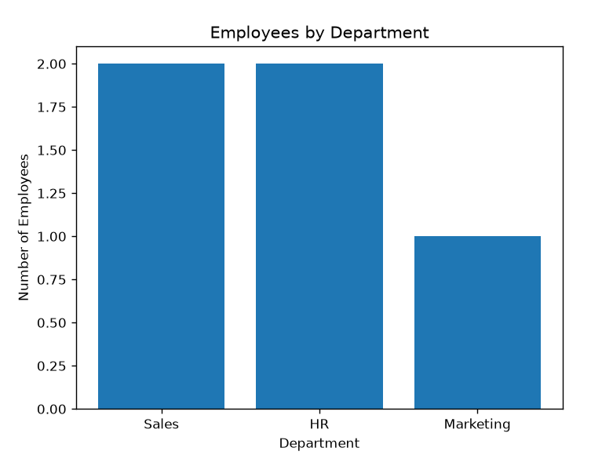

Set 4: Product Inventory Management
Dataset: Product Inventory
Product ID | Product Name | Quantity Available
1 | Product A | 250
2 | Product B | 175
3 | Product C | 300
4 | Product D | 200
5 | Product E | 220

1. Create a bar chart to visualize the quantity of each product in the inventory. Label the axes and title the chart.
2. Generate a stacked bar chart to show the quantity of each product within different product categories.
3. Build a scatter plot to explore the relationship between product price and quantity available. Explain the findings.
4. Develop a Tableau dashboard with the bar chart and stacked bar chart to allow users to interact with the data.
Python program:
import pandas as pd
import matplotlib.pyplot as plt

# Read CSV file
data = pd.read_csv("product_inventory.csv")

# 1. Bar Chart
plt.bar(data["Product Name"], data["Quantity Available"])
plt.title("Product Inventory")
plt.xlabel("Product Name")
plt.ylabel("Quantity Available")
plt.show()

# 2. Stacked Bar Chart
table = pd.crosstab(data["Category"], data["Product Name"],
values=data["Quantity Available"],
aggfunc="sum").fillna(0)

table.plot(kind="bar", stacked=True)
plt.title("Product Quantity by Category")
plt.xlabel("Category")
plt.ylabel("Quantity")
plt.show()

# 3. Scatter Plot
plt.scatter(data["Price"], data["Quantity Available"])
plt.title("Price vs Quantity Available")
plt.xlabel("Price")
plt.ylabel("Quantity Available")
plt.show()

print("Insight: The scatter plot helps identify whether higher-priced products have higher or lower inventory levels.")
Output:
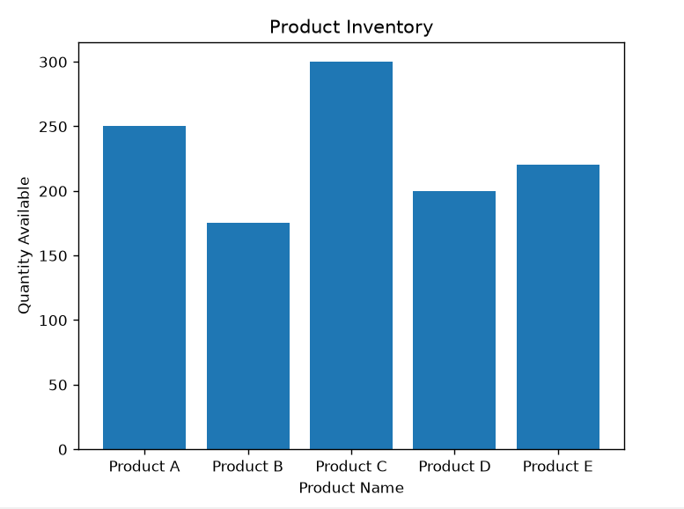

Set 5: Website Analytics
Dataset: Website Traffic
Date | Page Views | Click-through Rate
2023-01-01 | 1500 | 2.3%
2023-01-02 | 1600 | 2.7%
2023-01-03 | 1400 | 2.0%
2023-01-04 | 1650 | 2.4%
2023-01-05 | 1800 | 2.6%

1. Create a line chart to visualize the trend in daily page views over time. Label the axes and title the chart.
2. Generate a bar chart showing the top N days with the highest click-through rates. Label the chart elements.
3. Develop a stacked area chart to display the distribution of user interactions (likes, shares, comments) on a website.
4. Build a Tableau dashboard with the line chart and bar chart for interactive exploration of website traffic data.
Python program:
import pandas as pd
import matplotlib.pyplot as plt

# Read CSV file
data = pd.read_csv("Book5.csv")

# Convert Click-through Rate from percentage to number
data["Click-through Rate"] = data["Click-through Rate"].str.replace("%", "").astype(float)

# 1. Line Chart
plt.plot(data["Date"], data["Page Views"], marker="o")
plt.title("Daily Page Views")
plt.xlabel("Date")
plt.ylabel("Page Views")
plt.xticks(rotation=45)
plt.show()

# 2. Bar Chart (Top 5 Click-through Rates)
top = data.sort_values(by="Click-through Rate", ascending=False).head(5)

plt.bar(top["Date"], top["Click-through Rate"])
plt.title("Top Click-through Rates")
plt.xlabel("Date")
plt.ylabel("Click-through Rate (%)")
plt.xticks(rotation=45)
plt.show()

# 3. Stacked Area Chart
plt.stackplot(
data["Date"],
data["Likes"],
data["Shares"],
data["Comments"],
labels=["Likes", "Shares", "Comments"]
)

plt.title("User Interactions")
plt.xlabel("Date")
plt.ylabel("Count")
plt.legend()
plt.xticks(rotation=45)
plt.show()

print("Insight: The line chart shows page view trends, while the bar chart highlights the days with the highest click-through rates.")

Output:
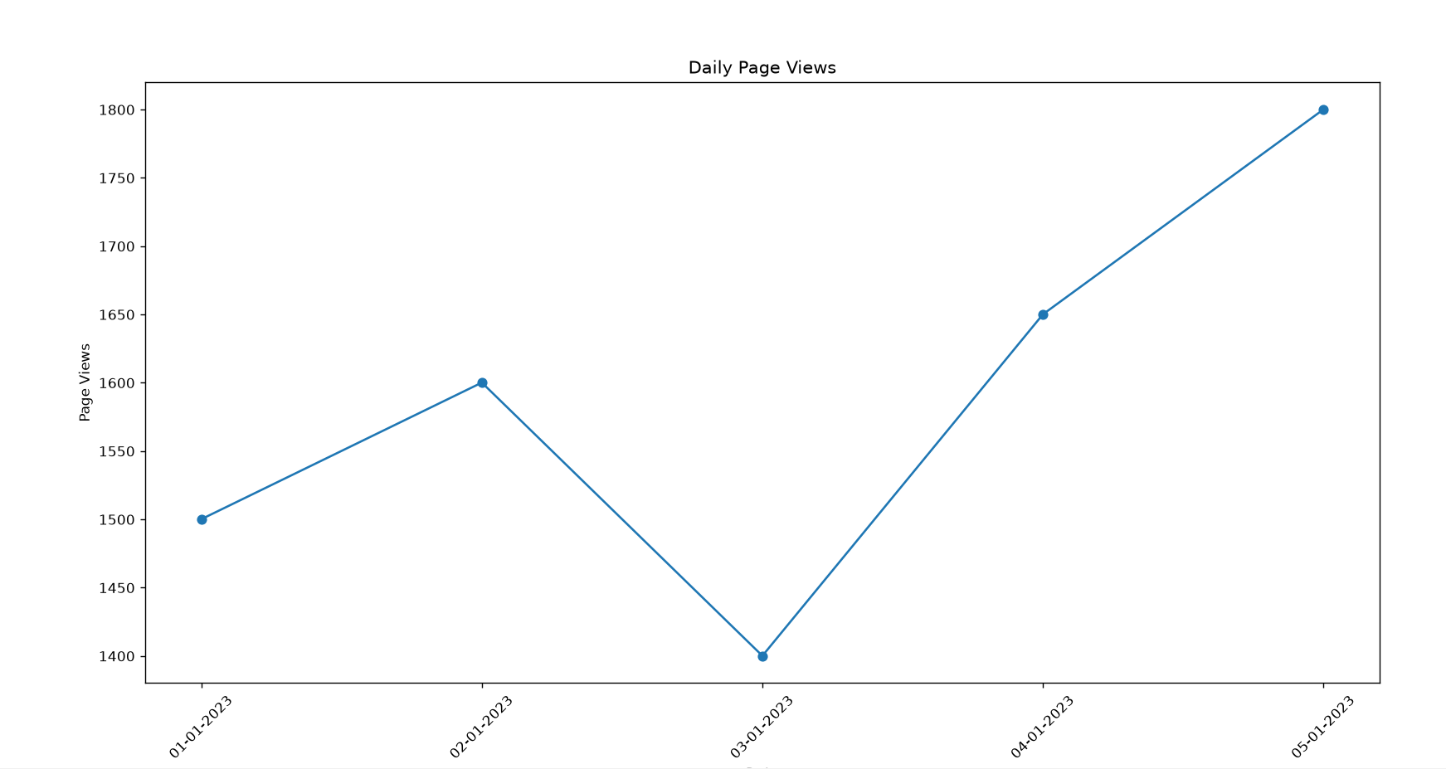

Set 6
Product Sales Analysis
Dataset: Monthly Product Sales
Product ID | Product Name | January Sales | February Sales | March Sales
1 | Product A | 2000 | 2200 | 2400
2 | Product B | 1500 | 1800 | 1600
3 | Product C | 1200 | 1400 | 1100

1. Create a grouped bar chart to visualize the sales of each product for the first quarter. Label the chart elements.
2. Generate a stacked area chart to represent the overall sales trend for all products over the three months.
3. Build a table to show the monthly sales data for each product. Label the table elements.
4. Develop a Tableau dashboard combining the grouped bar chart, stacked area chart, and the table for interactive exploration of sales data.

Python program:
import pandas as pd
import matplotlib.pyplot as plt

# Read CSV file
data = pd.read_csv("monthly_product_sales.csv")

# 1. Grouped Bar Chart
x = range(len(data))

plt.bar([i-0.2 for i in x], data["January Sales"], width=0.2, label="January")
plt.bar(x, data["February Sales"], width=0.2, label="February")
plt.bar([i+0.2 for i in x], data["March Sales"], width=0.2, label="March")

plt.xticks(x, data["Product Name"])
plt.title("Monthly Product Sales")
plt.xlabel("Product")
plt.ylabel("Sales")
plt.legend()
plt.show()

# 2. Stacked Area Chart
plt.stackplot(
["January", "February", "March"],
data["January Sales"],
data["February Sales"],
data["March Sales"],
labels=data["Product Name"]
)

plt.title("Overall Sales Trend")
plt.xlabel("Month")
plt.ylabel("Sales")
plt.legend()
plt.show()

# 3. Table
print("Monthly Product Sales")
print(data)

Output:
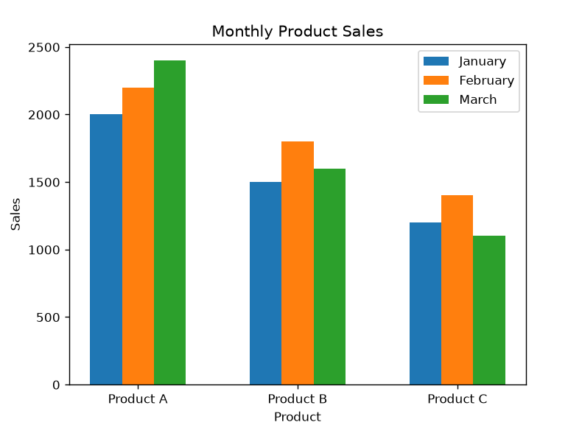

Set 7 Customer Demographics Analysis
Dataset: Customer Demographics
Customer ID | Age | Gender | Income (in $)
1 | 28 | Female | 50000
2 | 35 | Male | 60000
3 | 42 | Female | 75000
1. Create a bar chart to visualize the distribution of customer ages. Label the axes and title the chart.
2. Generate a pie chart to represent the distribution of customers by gender.
3. Build a table to show the demographic information for each customer. Label the table elements.
4. Develop a Tableau dashboard combining the bar chart, pie chart, and the table for interactive exploration of customer demographics.

Python Program:
import pandas as pd
import matplotlib.pyplot as plt

# Read CSV file
data = pd.read_csv("Book7.csv")

# 1. Histogram of Age
plt.hist(data["Age"], bins=5)
plt.title("Age Distribution")
plt.xlabel("Age")
plt.ylabel("Frequency")
plt.show()

# 2. Bar Chart of Gender
gender = data["Gender"].value_counts()

plt.bar(gender.index, gender.values)
plt.title("Gender Distribution")
plt.xlabel("Gender")
plt.ylabel("Count")
plt.show()

# 3. Scatter Plot (Age vs Income)
plt.scatter(data["Age"], data["Income (in $)"])
plt.title("Age vs Income")
plt.xlabel("Age")
plt.ylabel("Income ($)")
plt.show()

# 4. Table
print("Customer Data")
print(data)

Output:
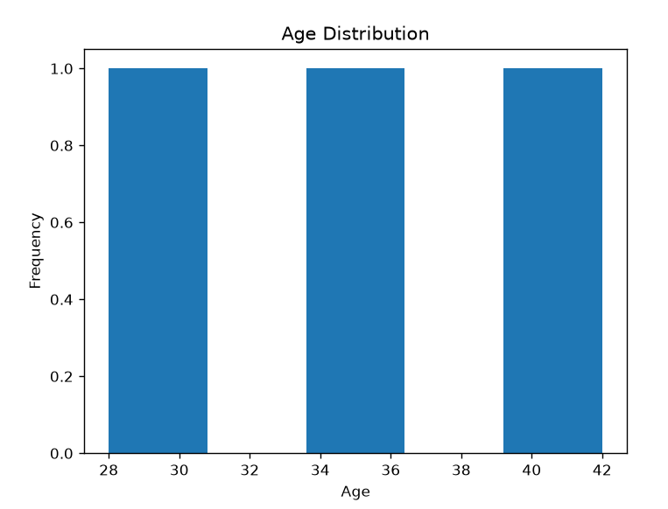

Set 8 Employee Performance Analysis
Dataset: Employee Performance
Employee ID | Department | Years of Service | Performance Score
1 | Sales | 5 | 85
2 | HR | 3 | 92
3 | Marketing | 7 | 78

1. Create a line chart to visualize the performance trend of employees over time. Label the axes and title the chart.
2. Generate a bar chart showing the distribution of employees across different departments. Label the chart elements.
3. Build a table to display the performance data for each employee. Label the table elements.
4. Develop a Tableau dashboard combining the line chart, bar chart, and the table for interactive exploration of employee performance data.

Python program:
import pandas as pd
import matplotlib.pyplot as plt

# Read CSV file
data = pd.read_csv("Book8.csv")

# 1. Line Chart
plt.plot(data["Employee ID"], data["Performance Score"], marker="o")
plt.title("Employee Performance Trend")
plt.xlabel("Employee ID")
plt.ylabel("Performance Score")
plt.grid(True)
plt.show()

# 2. Bar Chart
dept = data["Department"].value_counts()

plt.bar(dept.index, dept.values)
plt.title("Employees by Department")
plt.xlabel("Department")
plt.ylabel("Number of Employees")
plt.show()

# 3. Display Table
print("Employee Performance Data")
print(data)

Output:
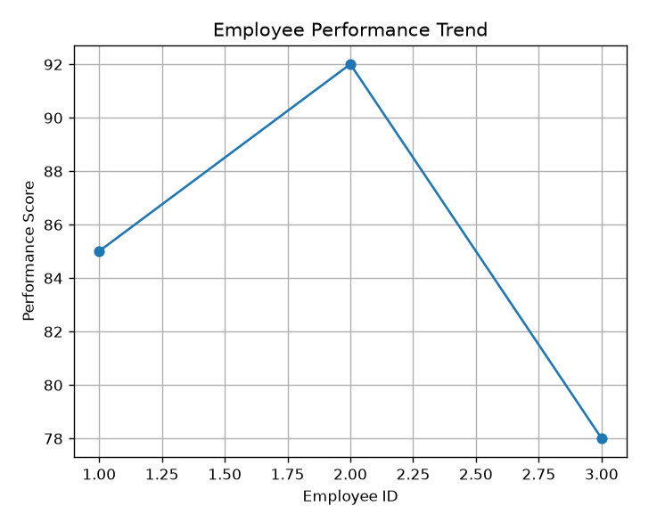

set 9
Dataset: Online_Learning_Activity.csv
Student_ID | Gender | Age | Course | Study_Time (hrs) | Videos_Watched | Quiz_Score | Login_Date
L01 | Male | 20 | R | 3.5 | 12 | 78 | 2025-01-05
L02 | Female | 22 | R | 4.2 | 15 | 85 | 2025-01-05
L03 | Male | 19 | SQL | 2.0 | 8 | 65 | 2025-02-08
L04 | Female | 21 | R | 5.0 | 18 | 92 | 2025-02-08
L05 | Male | 23 | R | 2.5 | 9 | 70 | 2025-03-12
L06 | Female | 20 | SQL | 4.0 | 14 | 88 | 2025-03-12

- Import the dataset in R. Plot a histogram for Quiz_Score. Draw a boxplot of Quiz_Score by Course. Add title and labels. Interpret student performance.
- Create a scatter plot using R programming between Study_Time and Quiz_Score. Represent Videos_Watched using bubble size. Apply transparency. Explain the learning pattern.
- Using R programming, convert Login_Date into Date format. Calculate average quiz score per month. Plot a line chart. Apply moving average smoothing. Identify the trend.
- Import Online_Learning_Activity.csv into Tableau. Create a bar chart showing average quiz score by Course. Create a scatter plot (Study Time vs Quiz Score). Add filter for Gender and Course. Design a mini interactive dashboard.
Python program:
import pandas as pd
import matplotlib.pyplot as plt

# Read CSV file
data = pd.read_csv("Book9.csv")

# 1. Histogram of Quiz Score
plt.hist(data["Quiz_Score"], bins=5)
plt.title("Quiz Score Distribution")
plt.xlabel("Quiz Score")
plt.ylabel("Frequency")
plt.show()

# 2. Boxplot of Quiz Score by Course
data.boxplot(column="Quiz_Score", by="Course")
plt.title("Quiz Score by Course")
plt.suptitle("")
plt.xlabel("Course")
plt.ylabel("Quiz Score")
plt.show()

# 3. Scatter Plot (Study Time vs Quiz Score)
plt.scatter(
data["Study_Time (hrs)"],
data["Quiz_Score"],
s=data["Videos_Watched"]*20,
alpha=0.5
)
plt.title("Study Time vs Quiz Score")
plt.xlabel("Study Time (hrs)")
plt.ylabel("Quiz Score")
plt.show()

# 4. Monthly Average Quiz Score
data["Login_Date"] = pd.to_datetime(data["Login_Date"])
data["Month"] = data["Login_Date"].dt.to_period("M")

avg = data.groupby("Month")["Quiz_Score"].mean()

# Moving Average
ma = avg.rolling(2).mean()

plt.plot(avg.index.astype(str), avg.values, marker="o", label="Average Score")
plt.plot(avg.index.astype(str), ma.values, marker="o", label="Moving Average")
plt.title("Average Monthly Quiz Score")
plt.xlabel("Month")
plt.ylabel("Average Quiz Score")
plt.legend()
plt.show()

Output:
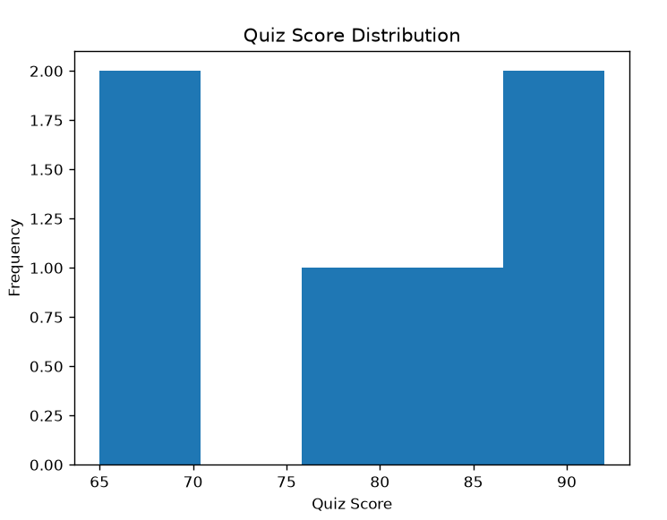

Set 10 Survey Responses Analysis
Dataset: Survey Responses

Survey ID | Question 1 | Question 2 | Question 3
1 | A | B | C
2 | B | A | D
3 | C | A | B

1. Create a grouped bar chart to visualize the distribution of answers for Question 1. Label the chart elements.
2. Generate a stacked bar chart to represent the overall distribution of responses for all three questions.
3. Build a table to show the survey response data for each survey. Label the table elements.
4. Develop a Tableau dashboard combining the grouped bar chart, stacked bar chart, and the table for interactive exploration of survey responses.

Python program:
import pandas as pd
import matplotlib.pyplot as plt

# Read CSV file
data = pd.read_csv("Book10.csv")

# 1. Grouped Bar Chart (Question 1 Responses)
q1 = data["Question 1"].value_counts()

plt.bar(q1.index, q1.values)
plt.title("Distribution of Question 1 Responses")
plt.xlabel("Answer")
plt.ylabel("Count")
plt.show()

# 2. Stacked Bar Chart (All Questions)
table = pd.DataFrame({
"Question 1": data["Question 1"].value_counts(),
"Question 2": data["Question 2"].value_counts(),
"Question 3": data["Question 3"].value_counts()
}).fillna(0)

table.plot(kind="bar", stacked=True)
plt.title("Survey Responses")
plt.xlabel("Answer")
plt.ylabel("Count")
plt.show()

# 3. Display Table
print("Survey Response Data")
print(data)

Output:
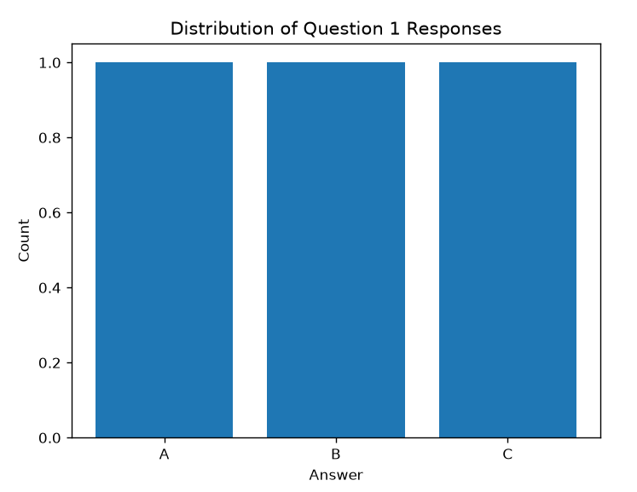

Set 11
Product Category Analysis
Dataset: Product Categories
Category | Sales (in $)
Electronics | 50000
Clothing | 35000
Appliances | 40000
1.Generate a funnel chart to analyze the sales conversion process for each product category. Label the stages and title the chart.
2. Build a table to display the sales data for each product category. Label the table elements.
3. Develop a Tableau dashboard combining the pie chart, funnel chart, and the table for interactive exploration of product category data.
4. Create a pie chart to represent the distribution of sales across product categories. Include labels.

Python program:
import pandas as pd
import matplotlib.pyplot as plt

# Read CSV file
data = pd.read_csv("Book11.csv")

# 1. Funnel Chart (Horizontal Bar Chart)
plt.barh(data["Category"], data["Sales (in $)"])
plt.title("Sales Conversion by Product Category")
plt.xlabel("Sales ($)")
plt.ylabel("Category")
plt.show()

# 2. Display Table
print("Product Category Sales")
print(data)

# 3. Pie Chart
plt.pie(
data["Sales (in $)"],
labels=data["Category"],
autopct="%1.1f%%"
)
plt.title("Sales Distribution by Product Category")
plt.show()

Output: 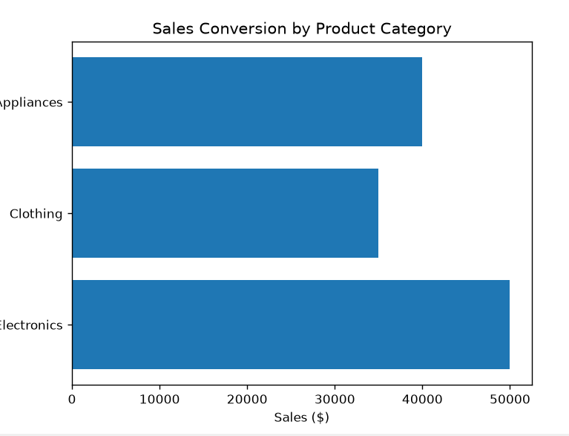
Set 12 :Dataset: Website Traffic

Date | Page Views | Click-through Rate
2023-01-01 | 1500 | 2.3%
2023-01-02 | 1600 | 2.7%
2023-01-03 | 1400 | 2.0%

1. Create a line chart to visualize the trend in daily page views over time. Label the axes and title the chart.
2. Generate a bar chart showing the top N days with the highest click-through rates. Label the chart elements.
3. Build a table to show the website traffic data for each day. Label the table elements.
4. Develop a Tableau dashboard combining the line chart, bar chart, and the table for interactive exploration of website traffic data.

Python program:
import pandas as pd
import matplotlib.pyplot as plt

# Read CSV file
data = pd.read_csv("Book12.csv")

# Convert Click-through Rate (%) to numeric
data["Click-through Rate"] = data["Click-through Rate"].str.replace("%", "").astype(float)

# 1. Line Chart
plt.plot(data["Date"], data["Page Views"], marker="o")
plt.title("Daily Page Views")
plt.xlabel("Date")
plt.ylabel("Page Views")
plt.xticks(rotation=45)
plt.show()

# 2. Bar Chart (Top N Days with Highest Click-through Rates)
top = data.sort_values(by="Click-through Rate", ascending=False)

plt.bar(top["Date"], top["Click-through Rate"])
plt.title("Top Click-through Rates")
plt.xlabel("Date")
plt.ylabel("Click-through Rate (%)")
plt.xticks(rotation=45)
plt.show()

# 3. Display Table
print("Website Traffic Data")
print(data)

Output:
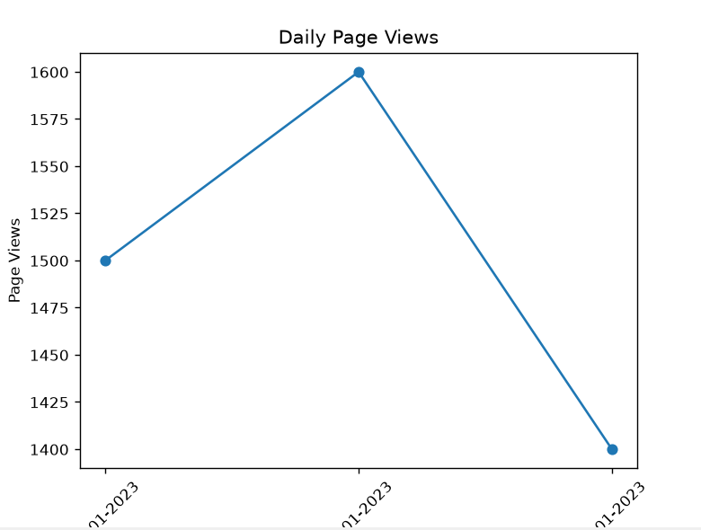

13. Dataset: Geographic Data

City | Population | Avg. Temperature | Elevation
City A | 500000 | 75 | 1000
City B | 700000 | 68 | 800
City C | 600000 | 80 | 1200

1. Create a map chart to visualize the distribution of cities on a geographic map. Label the map elements.
2. Generate a scatter plot to explore the relationship between average temperature and population size. Explain any insights.
3. Build a table to display the geographic data for each city. Label the table elements.
4.Develop a Tableau dashboard combining the map chart, scatter plot, and the table for interactive exploration of geographic data.

Python program:
import pandas as pd
import matplotlib.pyplot as plt

# Read CSV file
data = pd.read_csv("Book13.csv")

# 1. Simple City Plot (Map Placeholder)
plt.plot(data["City"], [1]*len(data), "o")
plt.title("City Distribution")
plt.xlabel("City")
plt.yticks([])
plt.show()

# 2. Scatter Plot
plt.scatter(data["Avg. Temperature"], data["Population"])
plt.title("Temperature vs Population")
plt.xlabel("Average Temperature")
plt.ylabel("Population")
plt.show()

print("Insight: The scatter plot helps compare population size with average temperature.")

# 3. Display Table
print("Geographic Data")
print(data)

Output:
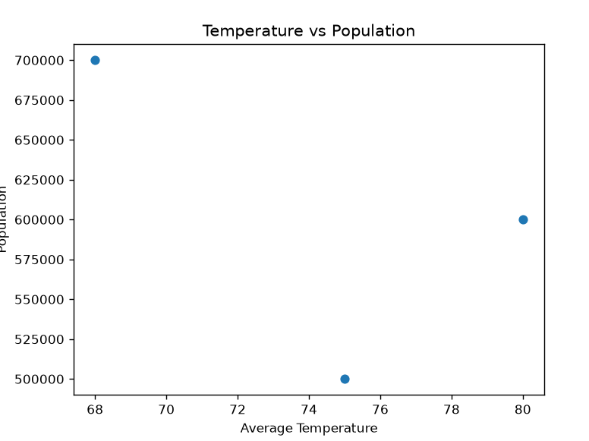

14. Dataset: Survey Results
Respondent | Question 1 | Question 2 | Question 3
1 | A | B | C
2 | B | A | D
3 | C | A | B

1. Create a stacked bar chart to display the distribution of answers for Question 1. Label the chart elements.
2. Generate a radar chart to visualize the overall pattern of responses across all three questions.
3. Build a table to show the survey response data for each respondent. Label the table elements.
4. Develop a Tableau dashboard combining the stacked bar chart, radar chart, and the table for interactive exploration of survey responses.

Python program:
import pandas as pd
import matplotlib.pyplot as plt
import math

# Read CSV file
data = pd.read_csv("Book14.csv")

# 1. Stacked Bar Chart
table = pd.DataFrame({
"Question 1": data["Question 1"].value_counts(),
"Question 2": data["Question 2"].value_counts(),
"Question 3": data["Question 3"].value_counts()
}).fillna(0)

table.plot(kind="bar", stacked=True)
plt.title("Survey Response Distribution")
plt.xlabel("Answer")
plt.ylabel("Count")
plt.show()

# 2. Radar Chart
labels = ["Question 1", "Question 2", "Question 3"]

values = [
data["Question 1"].value_counts().max(),
data["Question 2"].value_counts().max(),
data["Question 3"].value_counts().max()
]

# Create angles using math
angles = []
for i in range(len(labels)):
angles.append(2 * math.pi * i / len(labels))

angles.append(angles[0])
values.append(values[0])

ax = plt.subplot(111, polar=True)
ax.plot(angles, values, marker="o")
ax.fill(angles, values, alpha=0.3)
ax.set_xticks(angles[:-1])
ax.set_xticklabels(labels)
plt.title("Survey Response Pattern")
plt.show()

# 3. Display Table
print("Survey Results")
print(data)

Output:
